**LAPORAN TUGAS PRAKTIKUM**

**PEMROGRAMAN BERBASIS WEB**

**Oleh**

**Mochamad Zaidan Al Rasyid**

**4522210118**

**Dosen**

**Adi Wahyu Pribadi**

**S-1 Teknik Informatika**

**Universitas Pancasila**

**2024/2025**

**1.Setup Laravel**

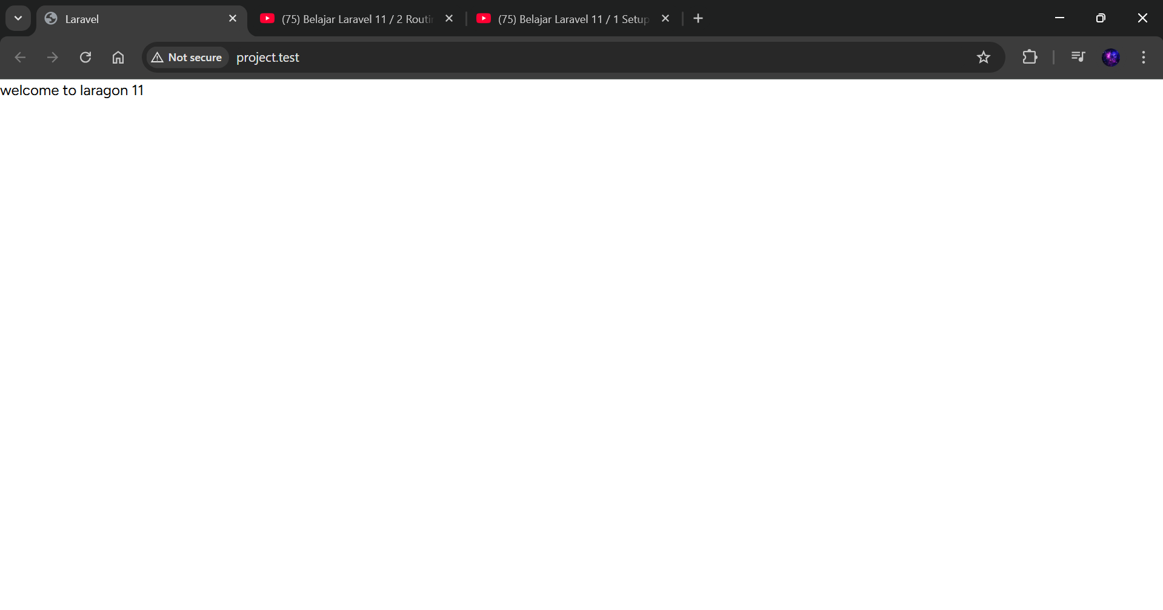

**2.Routing danView**

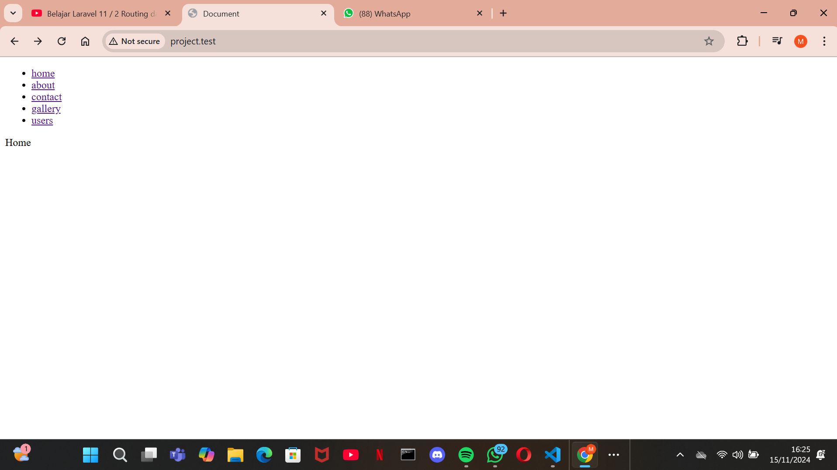

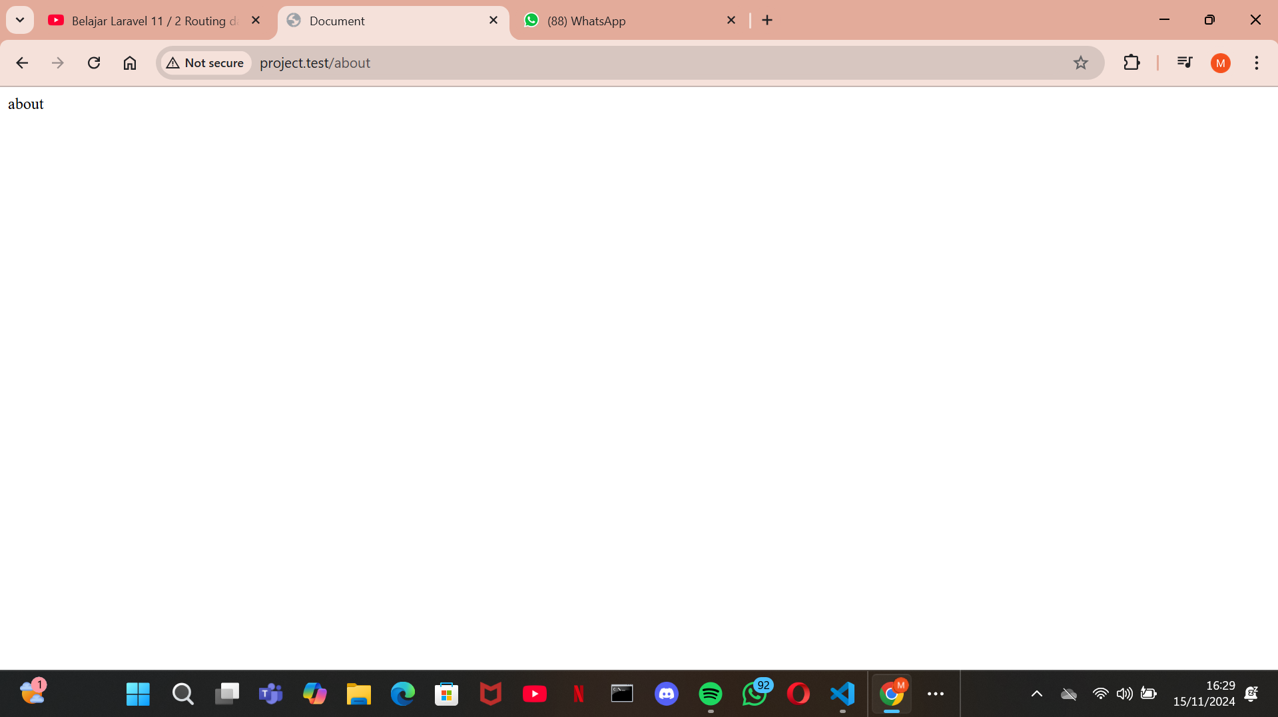

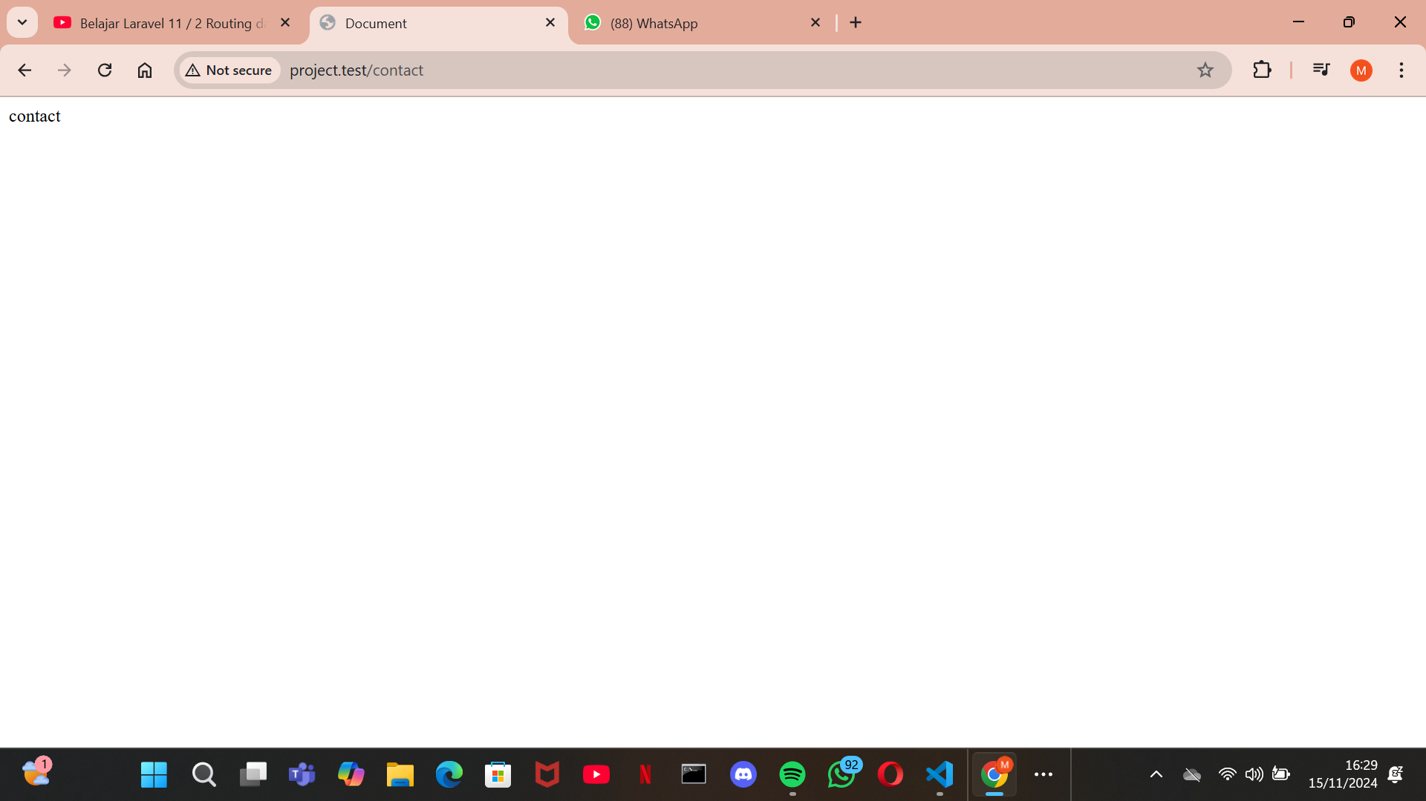

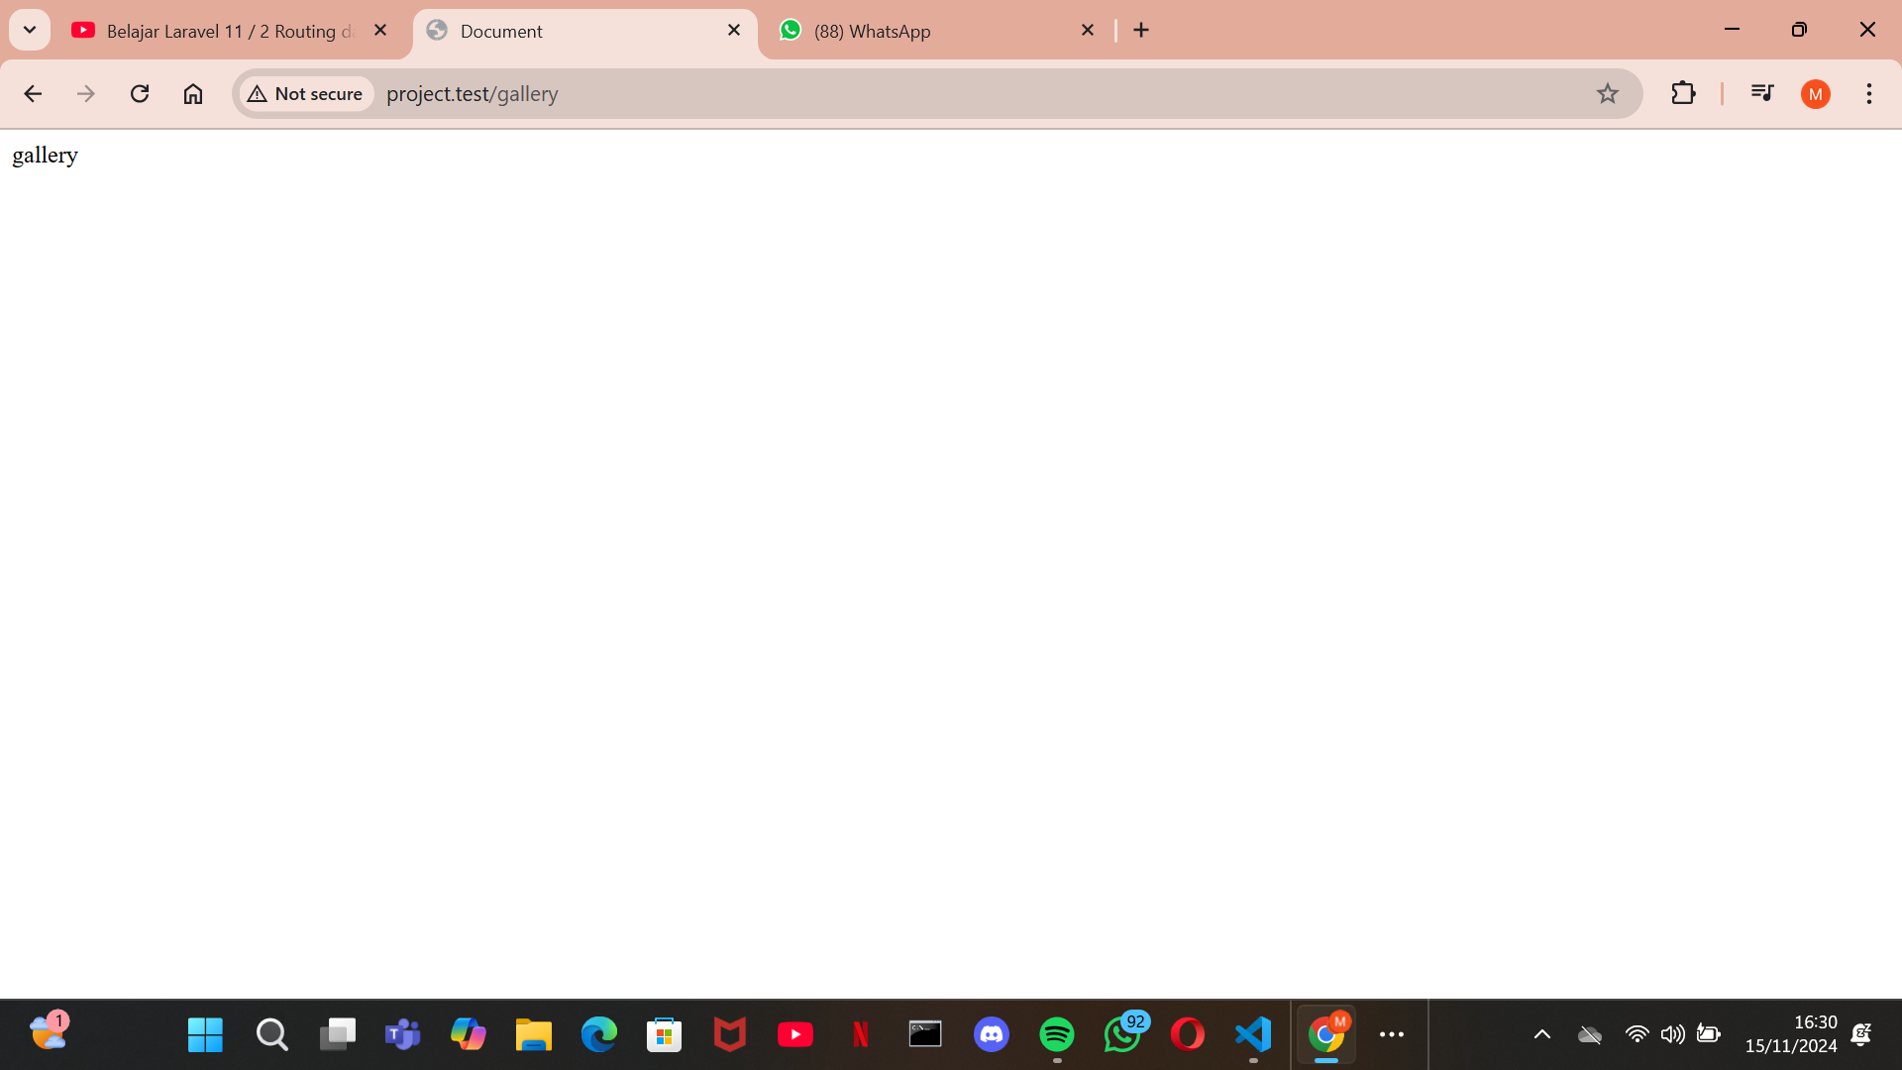

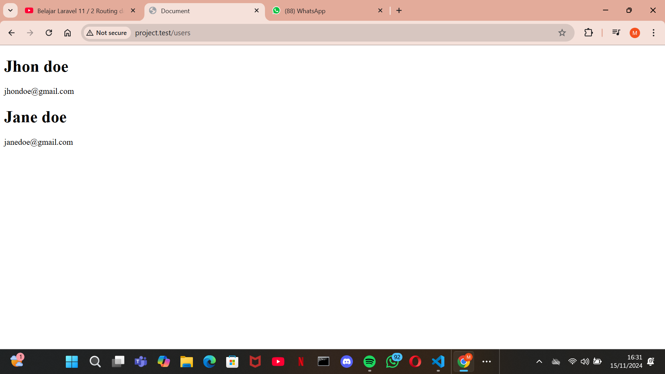

**3. stylist**

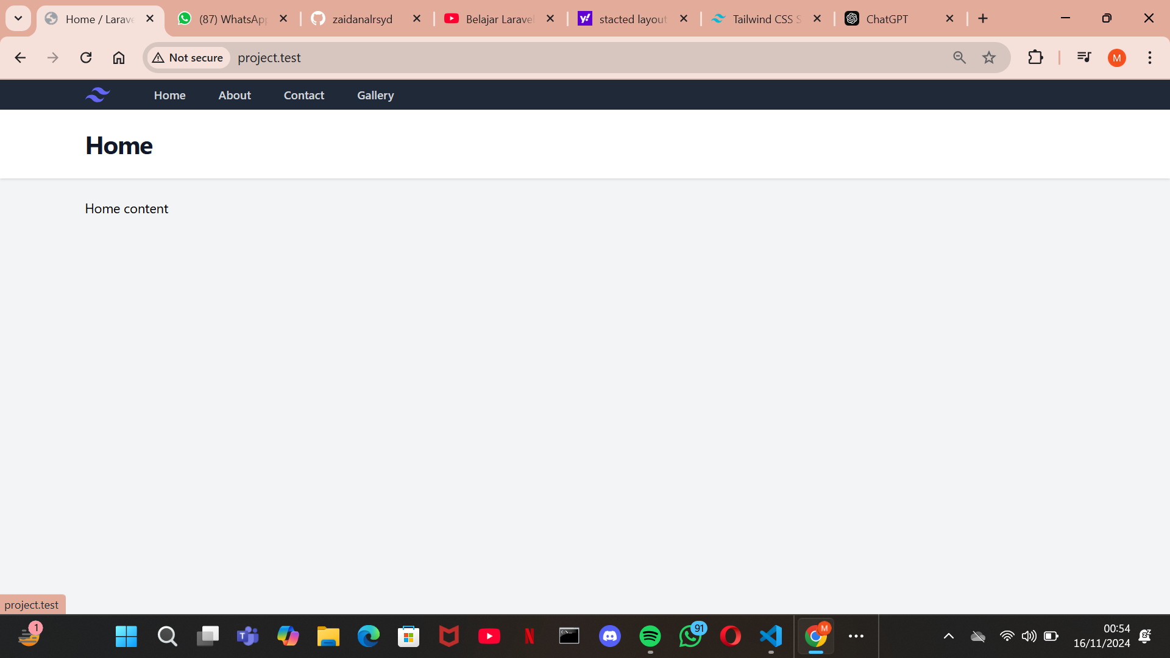

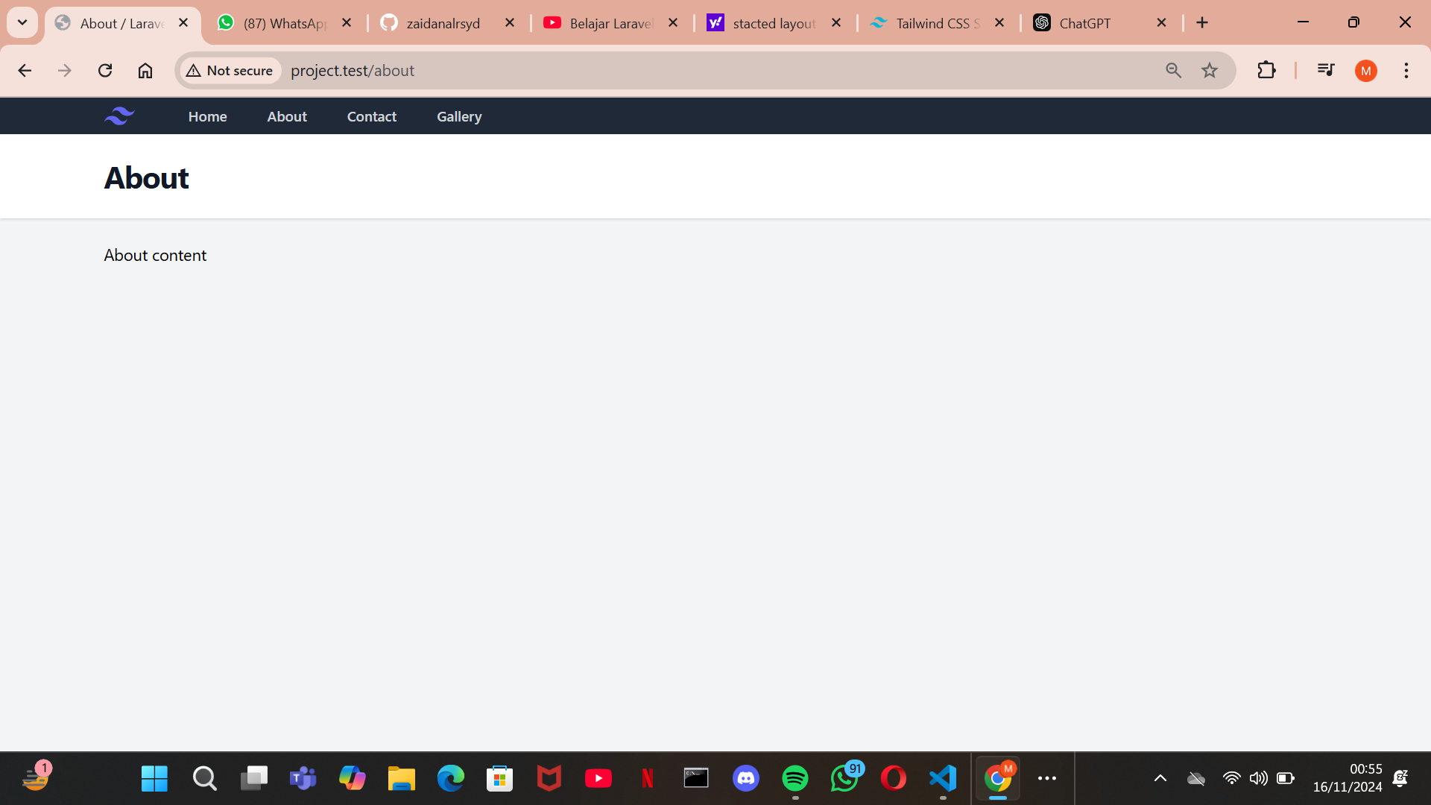

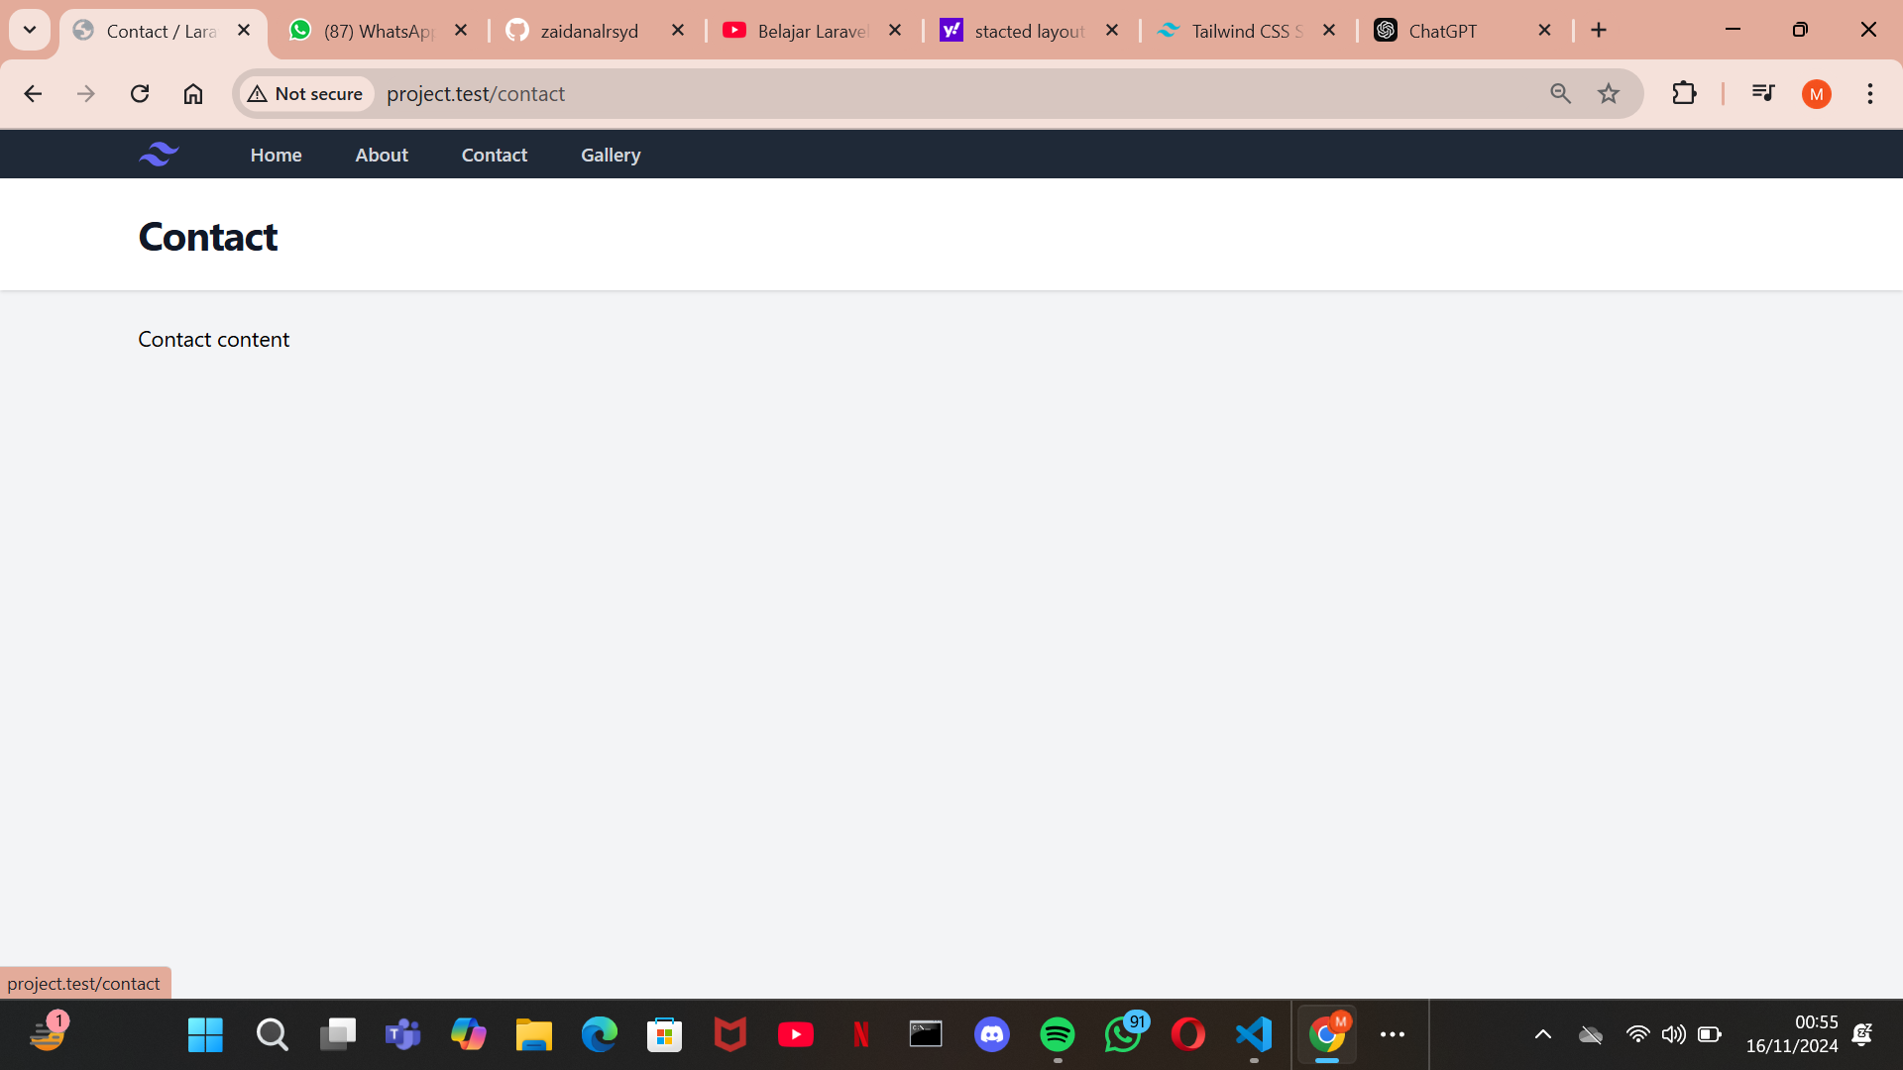

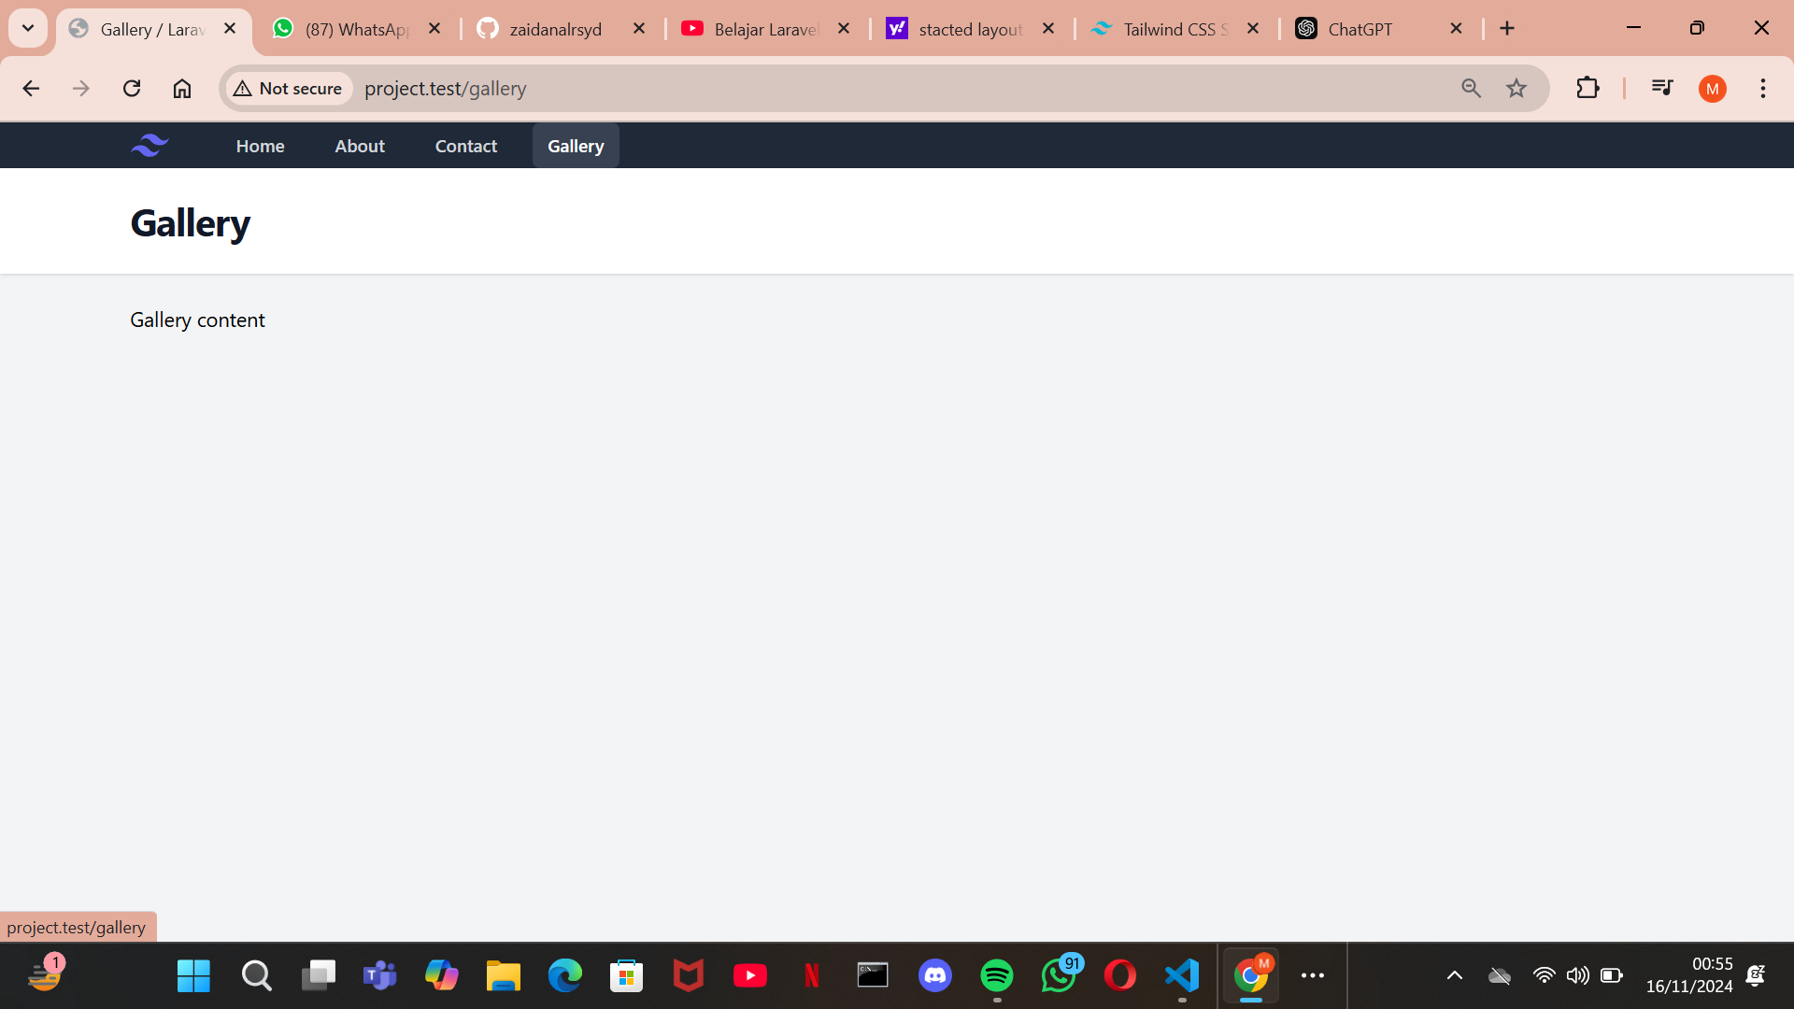

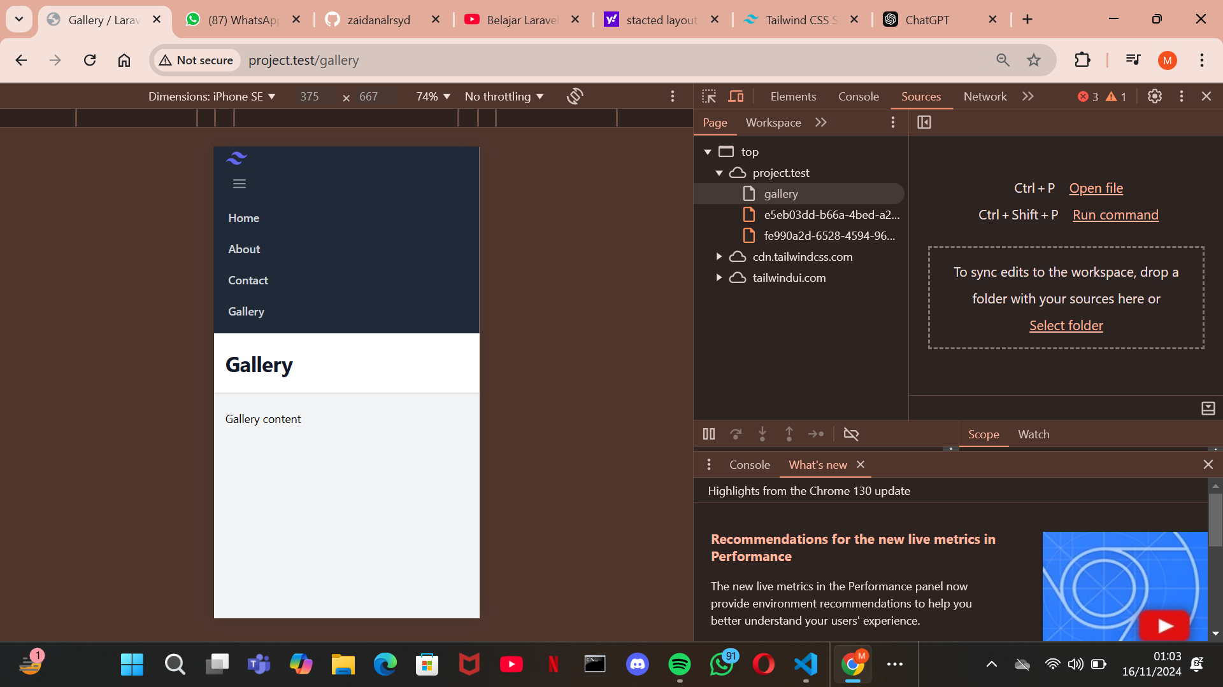

**4. Active State**

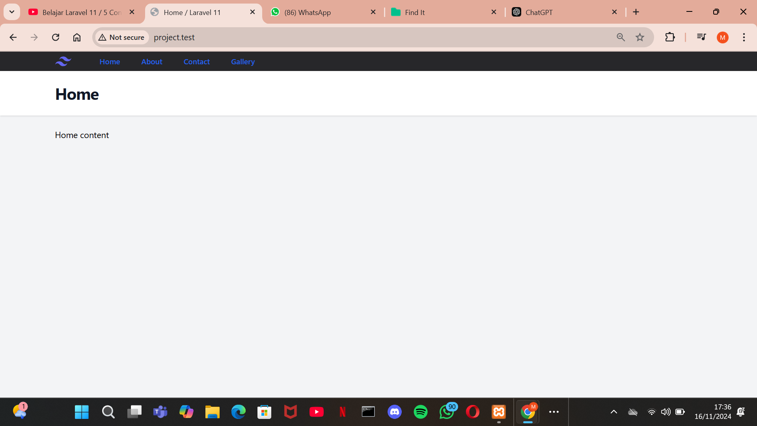

**5. Contoller**

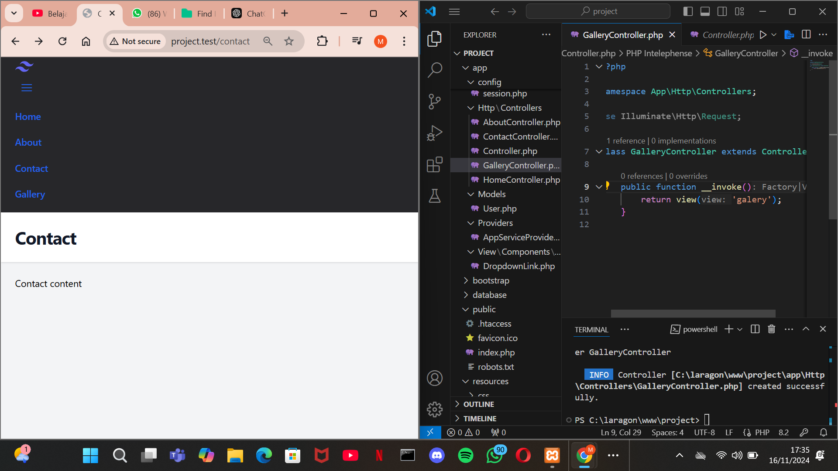

**6. Migration**

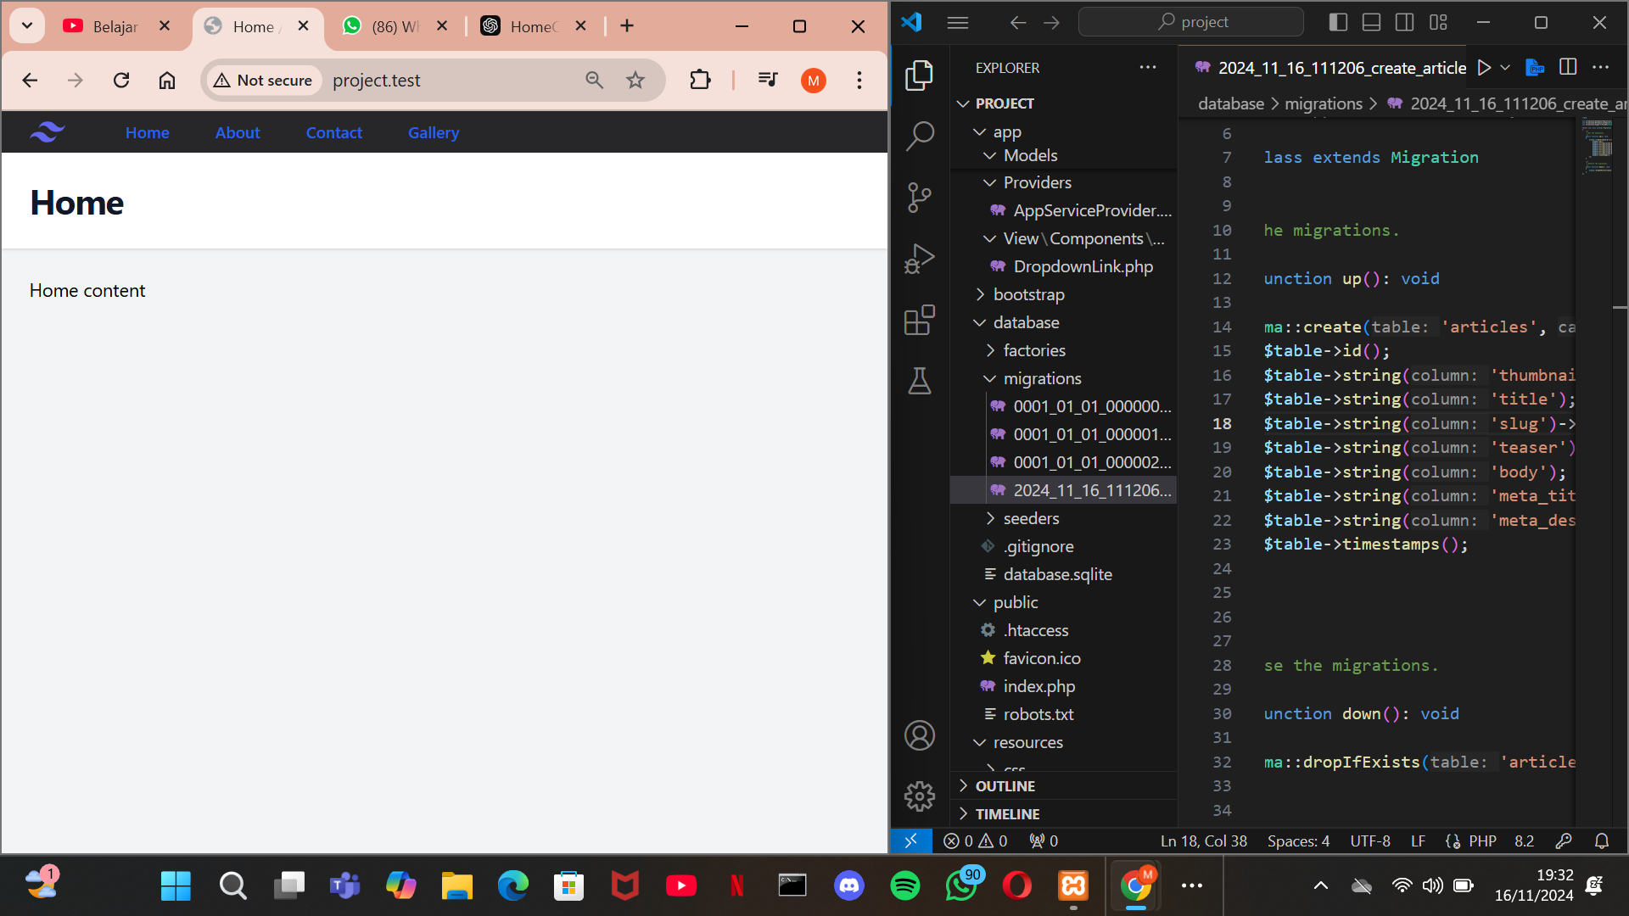

**Link Github :**

[**https://github.com/zaidanalrsyd/PBW**](https://github.com/zaidanalrsyd/PBW)

**7. DB Facedes**

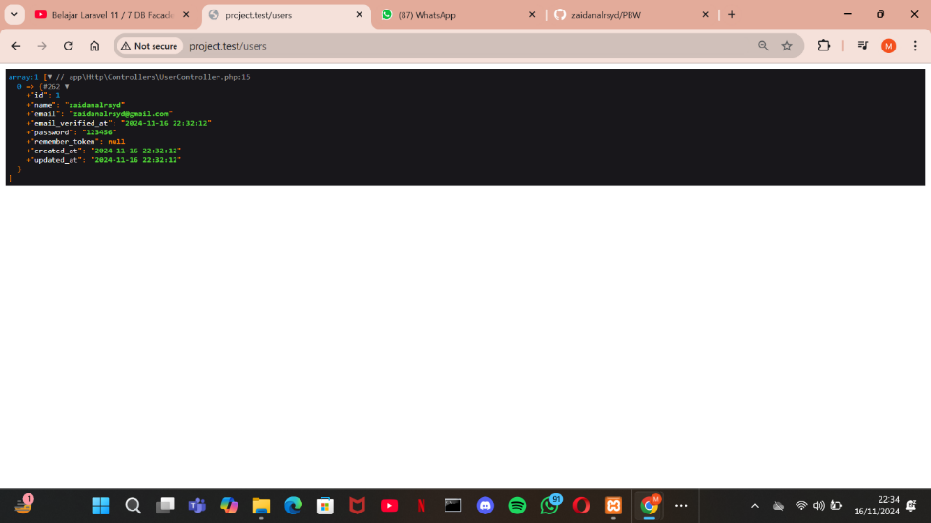

**8. Model dan Fetching**

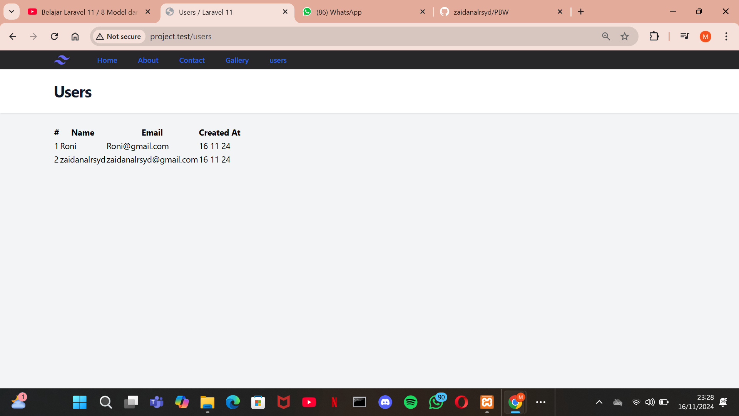

**9. Kondisi Dalam Komponen**

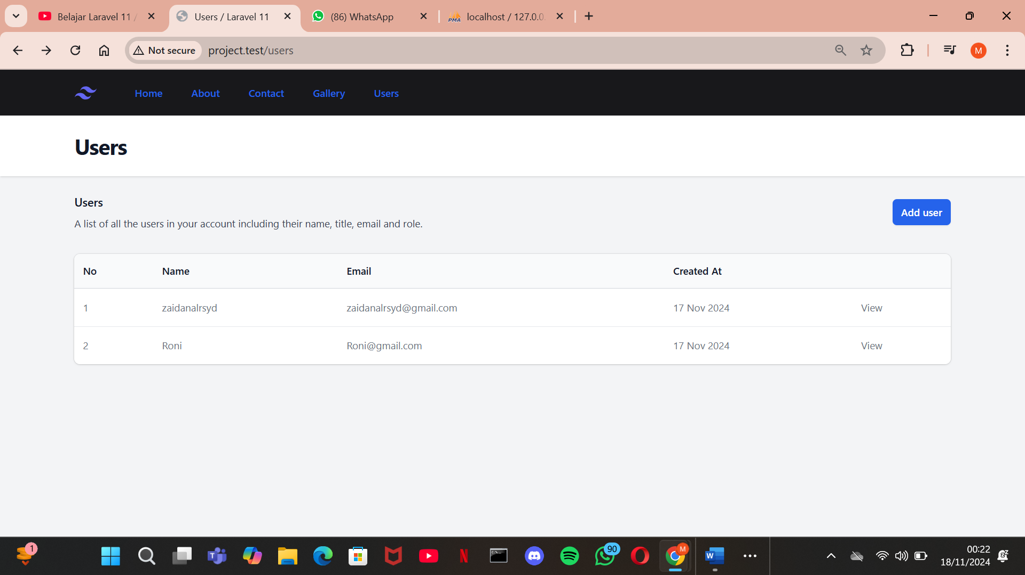

**10.  Fillable and Guarded**

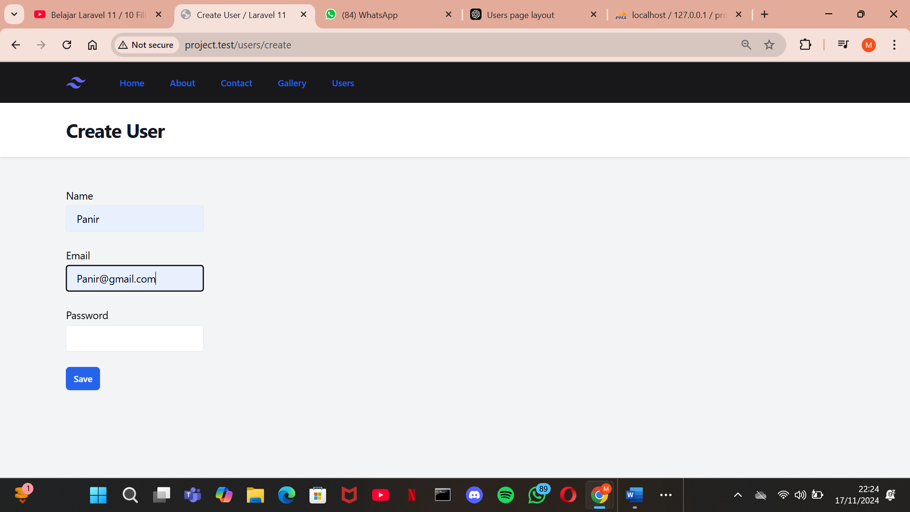

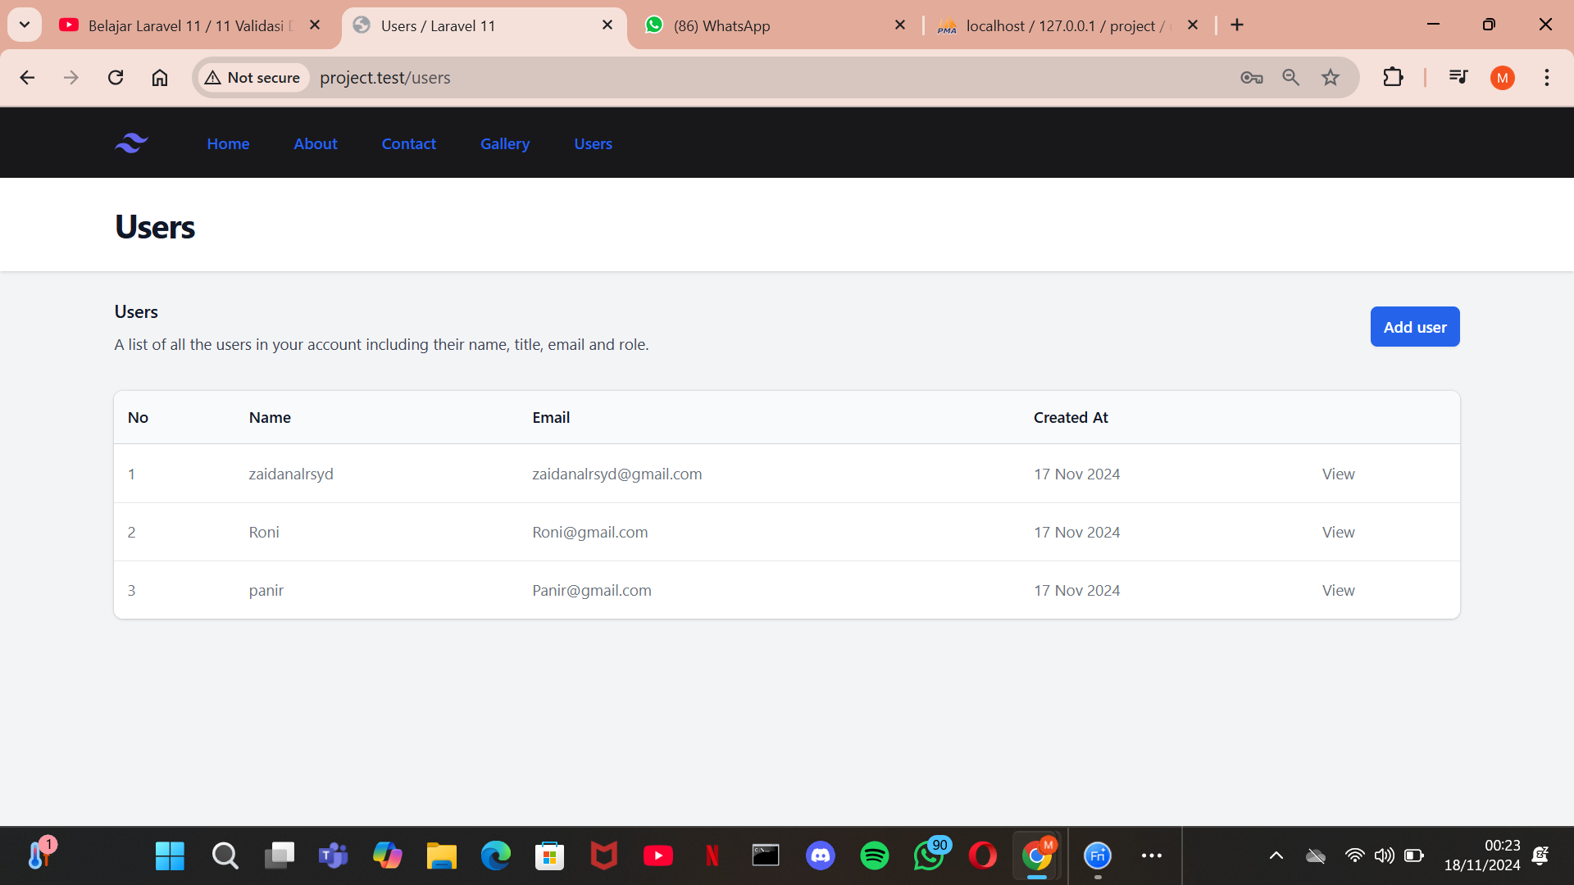

**11. Validasi Data**

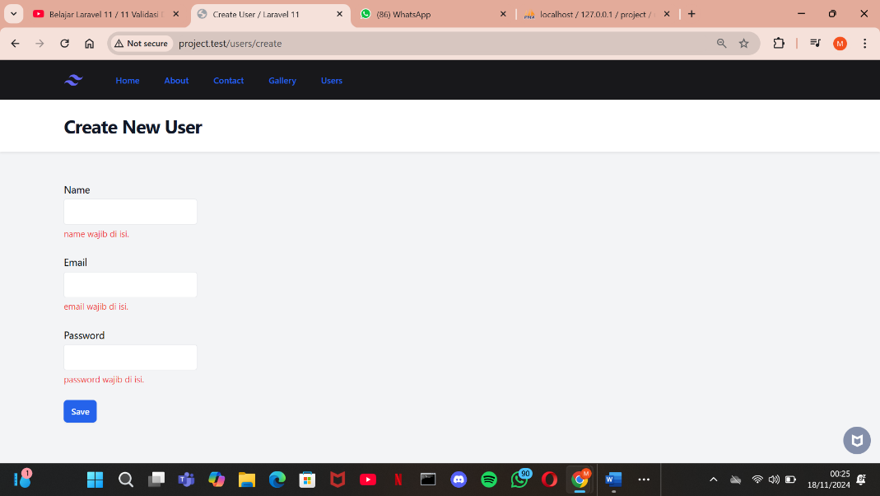

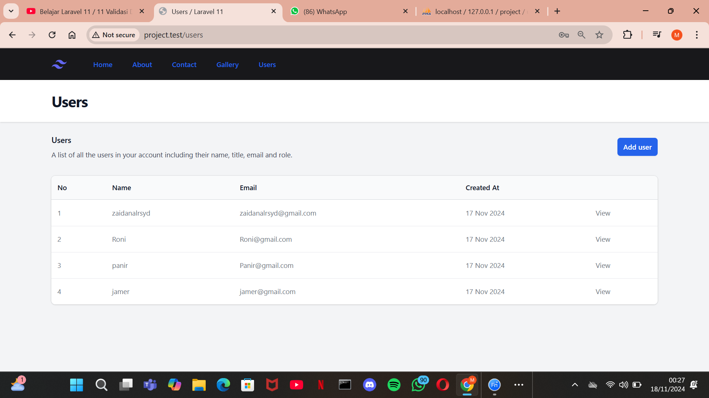

**12. Route Wildcard**

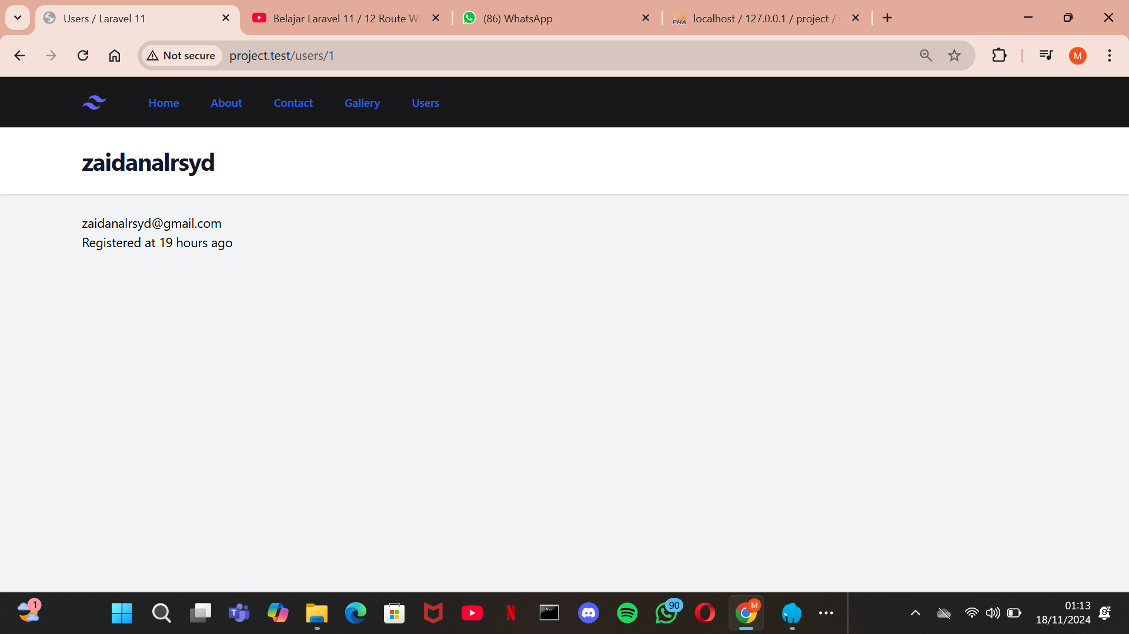

**Link Github :**

[**https://github.com/zaidanalrsyd/PBW**](https://github.com/zaidanalrsyd/PBW)